ArtConnect Application

Project Structure

Step 1: Understanding ArtConnect and Defining the Functional Scope
Tasks:
  - 1. Exploring the provided application
- Import the ArtConnect Java project into your IDE.
github link : https://github.com/PaulGournay/ArtConnectPro-App.git
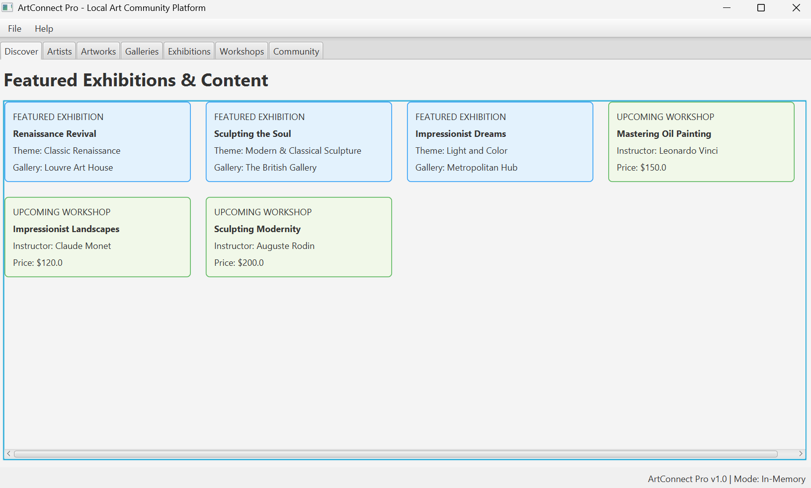
- Launch the application (as-is, it uses in-memory services and dummy data).

We see clearly the app starting in the In-Memory Mode

  - 2. Functional analysis
- List the main features you see in the interface (from the user’s perspective).
First we have 7 pages for the user:
- The discover dashboard: We can view a a selection of featured exhibitions and upcoming workshops with their informations.
- Artists directory: list of artists with the ability to filter by discipline or by name.
- Artwork gallery: Access to a catalogue of work including the details on them.
- Galery management: list local art venue including address and client rate.
- Exhibition calendar: Track art events organized by theme, location and start date.
- Educational workshops: Explore artist training sessions filtered by instructor, price, and skill level
- Community page: View a list of registered community members promoting local art
- Identify at least two roles or user profiles (e.g., “organizer” vs. “visitor”; even if the current interface does not yet handle authentication, you can define them conceptually).

- Visitor:
-Browses the artists, artwork, exhibitions…
-Can discover the upcoming workshops and events

- Art organizer / Administrator:
-Manage the list of artists and their profile
-uploads new artworks and their availability
-Organizes and schedules exhibitions and workshops.

- Draw a use case diagram (UML) representing the target features of ArtConnect from the actors’ perspective.
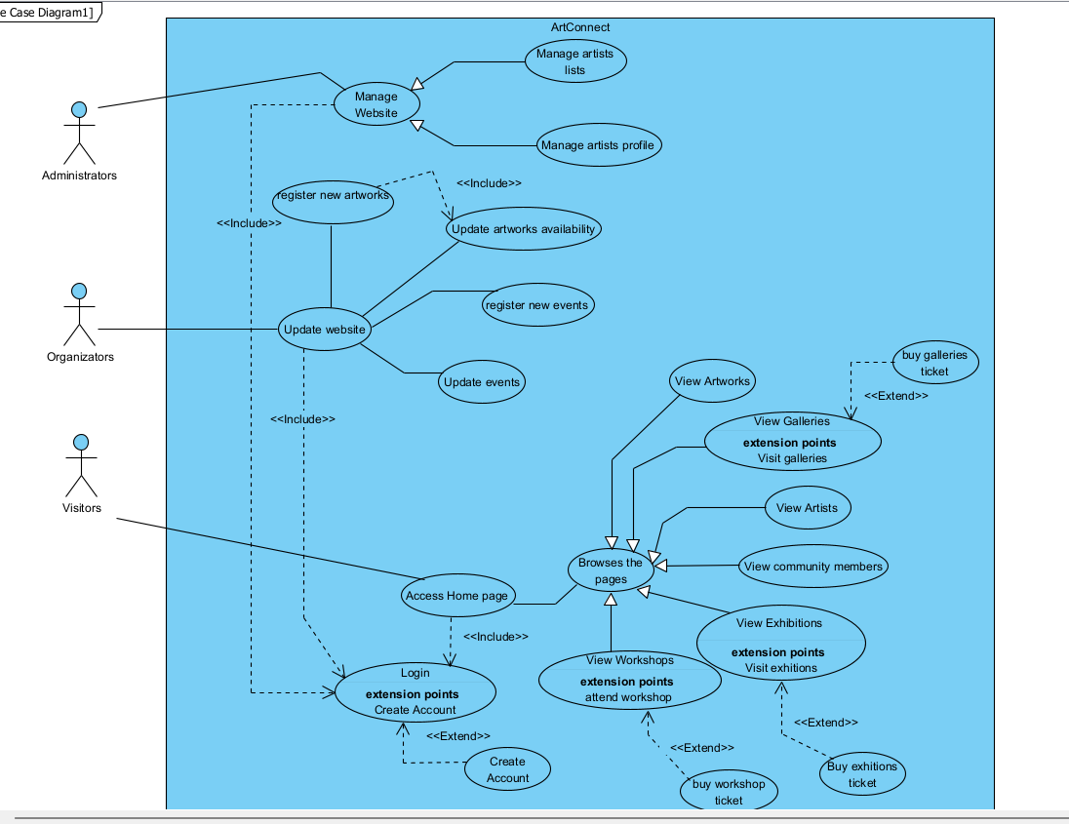

- Add a legend indicating which features are already present in the interface and which are planned for later (optional/evolutionary).
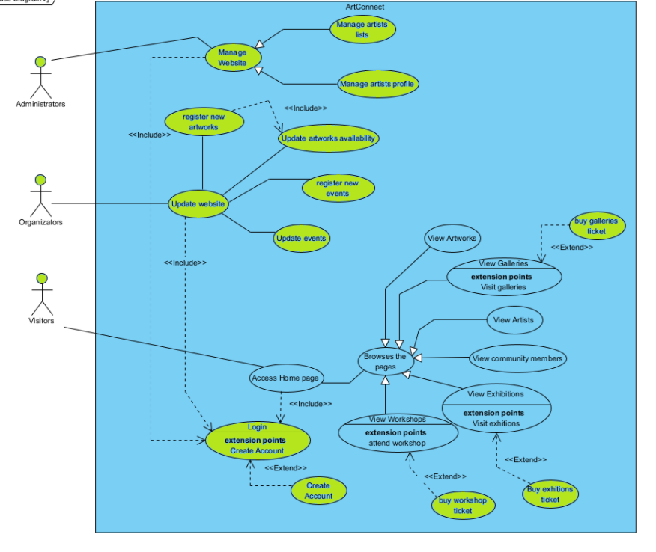
In blue : it’s the already present in the interface
In green : it’s what we have planned for later

  - 3. Static design
- Read the README file carefully.
- Understand the relationships between the different application classes, as well as the overall architecture.
- Create one (or more) class diagram(s) for the code. Preferably represent the model classes in a separate diagram.
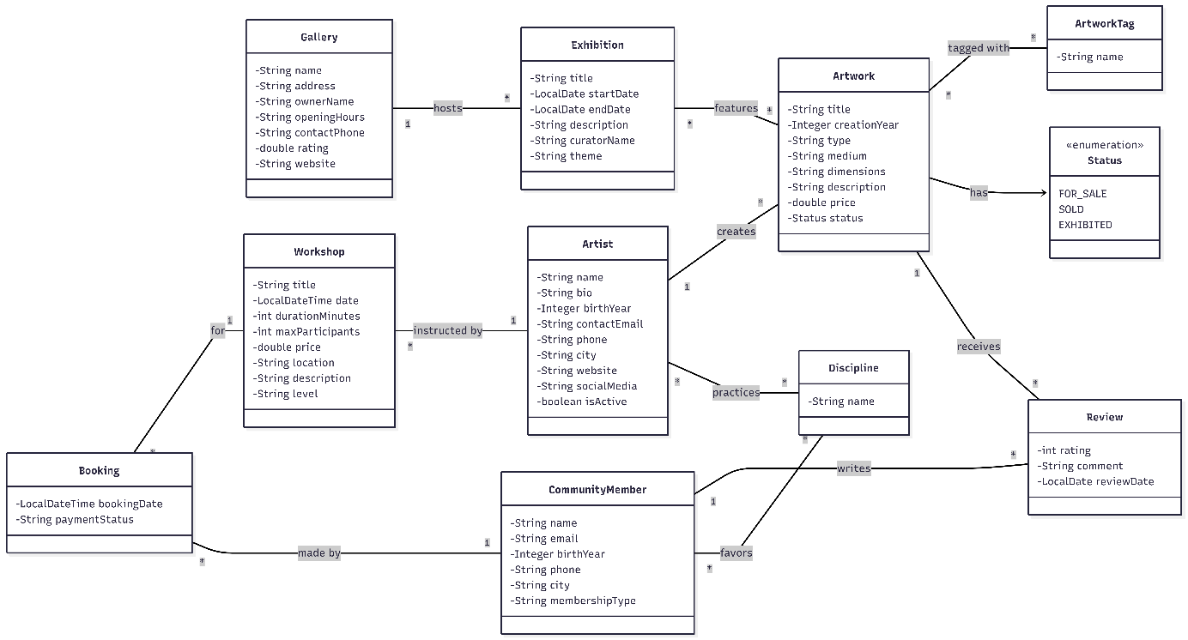

Step 2: Conceptual and Logical Modeling of the ArtConnect Database
Objective: Design the conceptual and logical models of the database from the identified features, applying normalization principles (up to 3NF).
Tasks:

1. Identify entities and relationships
- Based on the interface and business needs, identify the different entities and their attributes.
- Define the functional dependencies between the different attributes.
- Think about the identifiers to define for each entity. You can choose one (or more) existing attribute(s) from the associated class, or define a new one.

We have several entities:
Gallery (gallery_id, name, address, owner_name, opening_hours, contact_phone, rating, website)
- Identifiers: Maybe multiple gallery with the same name so we create a new id : gallery_id
- Dependencies: A gallery will contain the multiple exhibition, every exhibition is linked to a gallery

Exhibition (exhibition_id, title, start_date, end_date, description, curator_name, theme, #gallery_id)
- Dependencies:
  - An exhibition is always host in a gallery so we must introduce a FK on Gallery
  - Every Artwork are linked to a exhibition because there is no duplicate, but we want to track them over time, further explanation in the Artwork dependencies specification
- Identifiers: Maybe multiple exhibitions with the same name so we create a new id : exhibition_id

Artist (artist_id, name, birth_year, contact_email, phone, city, website, social_media, is_active)

- Identifiers: Maybe multiple artist can have the same name so we create a new id : artist_id
- Dependencies:
  - An Artist can create multiple artwork, so we must link every artwork a specific artist_id
  - An Artist can instructed multiple Workshop so we must link each workshop to a specific artist _id
  - An Artist can practice multiple discipline so we are going to link each artist to the discipline they are practicing, since they can practice multiple, we have to store these values in a new table : Practices (#artist_id, #discipline_id)

Artwork (artwork_id, title, creation_year, type, medium, dimensions, description, price, status,#artist_id)
- Identifiers: Maybe multiple artwork with the same name so we create a new id : artwork_id
- Dependencies:
  - An artwork can be linked to multiple exhibitions over time and we want to track these change over time, so we must have a way to store the changes, let us introduce Features (#artwork_id, #exhibition_id, arrival_date)
  - An artwork is created by an artist so we must introduce a FK key to artist
  - An artwork can received multiple review by different distinct user, so we must store those in the review table.
Tag (tag_id, name)
- Dependencies: An artwork is always link to one or multiple tag so we must create a table that link tag table with the artwork table : Tagged (#artwork_id, #tag_id)
- Identifiers: we add a id for the artwork so that it’s easier to do queries

CommunityMember (user_id, name, email, birth_year, phone, city, membership_type)
- Identifiers: Maybe multiple user could have the same name so we create a new id : user_id
- Dependencies:
  - A community member can writes reviews however, as we can writes multiple review, we must store the user_id in the review table
  - A community member favors specific discipline, as he can favor multiple, we have to store the user_id in a new table, let us introduce Favors(#user_id, #discipline_id)
  - A community member can book workshop however, as he can book multiple workshop, we must store the user_id in the booking table
Discipline (discipline_id, name)
- Identifiers: It easier to introduce a discipline_id to manage the relations has it has dependencies with other entities
- Dependencies:
  - A user can favor multiple discipline so we must have a relation discipline and user : Favors (#user_id, #discipline_id)
  - An artist can belong to multiple disciplines so we must introduce a relation between discipline and artist: Practices (#artist_id, #discipline_id)
Review(#user_id, #artwork_id, rating, comment, review_date)
- Identifiers: As a user can only perform one review per artwork, we don’t have to introduce a review_id, as #user_id & #artwork_id form the PK of the table
- Dependencies:
  - A user can only write 1 review for a specific artwork so we must have a link to user_id and artwork_id as foreign keys
  - An artwork can receive multiple reviews from different users so we must store them

Booking(#user_id, #workshop_id, bookingDate, paymentStatus)
- Identifiers: As a user can’t make multiple booking for workshop, we can use #user_id and workshop_id as a PK for this table.
- Dependencies:
  - Each booking must concern a specific workshop so we must store the workshop_id
  - A user can book several workshops so we must store the user_id related to a specific workshop_id

2. Create a Conceptual Data Model (CDM)
- Use an Entity-Relationship diagram (ERD) to represent entities, attributes, and relationships.
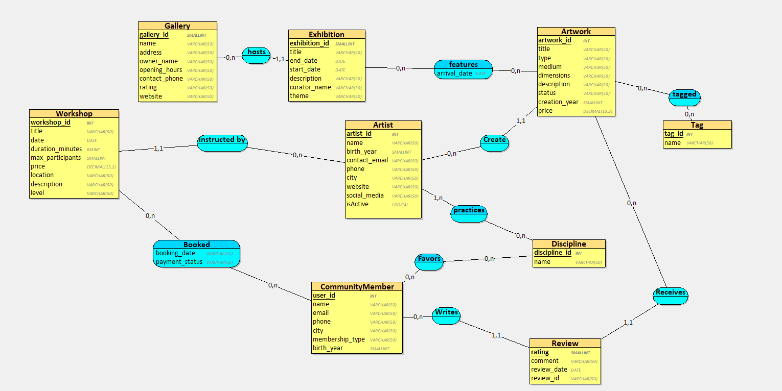

3. Create a Logical Data Model (LDM)
- Transform the CDM into an LDM by adding primary keys, foreign keys, and data types.
- Normalize the database up to the 3rd Normal Form (3NF).

Gallery = (gallery_id SMALLINT, name VARCHAR(50), address VARCHAR(50), owner_name VARCHAR(50), opening_hours VARCHAR(50), contact_phone VARCHAR(50), rating VARCHAR(50), website VARCHAR(50));
Exhibition = (exhibition_id SMALLINT, title VARCHAR(50), end_date DATE, start_date DATE, description VARCHAR(50), curator_name VARCHAR(50), theme VARCHAR(50), #gallery_id);
Artist = (artist_id INT, name VARCHAR(50), birth_year SMALLINT, contact_email VARCHAR(50), phone VARCHAR(50), city VARCHAR(50), website VARCHAR(50), social_media VARCHAR(50), isActive LOGICAL);
Workshop = (workshopid INT, title VARCHAR(50), date DATE, duration_minutes BIGINT, max_participants SMALLINT, price DECIMAL(15,2), location VARCHAR(50), description VARCHAR(50), level VARCHAR(50), #artist_id);
Artwork = (artwork_id INT, title VARCHAR(50), type VARCHAR(50), medium VARCHAR(50), dimensions VARCHAR(50), description VARCHAR(50), status VARCHAR(50), creation_year SMALLINT, price DECIMAL(15,2), #artist_id);
Discipline = (discipline_id INT, name VARCHAR(50));
CommunityMember = (user_id INT, name VARCHAR(50), email VARCHAR(50), phone VARCHAR(50), city VARCHAR(50), membership_type VARCHAR(50), birth_year SMALLINT);
Review = (review_id INT, rating BYTE, comment VARCHAR(50), review_date DATE, #artwork_id, #user_id);
Tag = (tag_id INT, name VARCHAR(50));
Booking = (booking_id INT, booking_date DATETIME, payment_status VARCHAR(50), #user_id, #workshop_id);
Favors = (#discipline_id, #user_id);
features = (exhibition_id, #artwork_id, arrival_date DATE);
practices = (artist_id, #discipline_id);
tagged = (artwork_id, #tag_id);

4. Create the database schema
- Write SQL scripts to create tables, define constraints (e.g., primary keys, foreign keys, NOT NULL), and establish relationships.
CREATE TABLE Gallery (
gallery_id SMALLINT PRIMARY KEY,
name VARCHAR(50) NOT NULL,
address VARCHAR(50),
owner_name VARCHAR(50),
opening_hours VARCHAR(50),
contact_phone VARCHAR(50),
rating VARCHAR(50),
website VARCHAR(50)
);
CREATE TABLE Artist (
artist_id INT PRIMARY KEY,
name VARCHAR(50) NOT NULL,
birth_year SMALLINT,
contact_email VARCHAR(50),
phone VARCHAR(50),
city VARCHAR(50),
website VARCHAR(50),
social_media VARCHAR(50),
isActive BOOLEAN
);
CREATE TABLE Discipline (
discipline_id INT PRIMARY KEY,
name VARCHAR(50) NOT NULL
);
CREATE TABLE CommunityMember (
user_id INT PRIMARY KEY,
name VARCHAR(50) NOT NULL,
email VARCHAR(50) NOT NULL,
phone VARCHAR(50),
city VARCHAR(50),
membership_type VARCHAR(50),
birth_year SMALLINT
);
CREATE TABLE Tag (
tag_id INT PRIMARY KEY,
name VARCHAR(50) NOT NULL
);
CREATE TABLE Exhibition (
exhibition_id SMALLINT PRIMARY KEY,
title VARCHAR(50) NOT NULL,
start_date DATE,
end_date DATE,
description VARCHAR(50),
curator_name VARCHAR(50),
theme VARCHAR(50),
gallery_id SMALLINT,
FOREIGN KEY (gallery_id) REFERENCES Gallery(gallery_id) ON DELETE CASCADE
);
CREATE TABLE Workshop (
workshopid INT PRIMARY KEY,
title VARCHAR(50) NOT NULL,
date DATE,
duration_minutes BIGINT,
max_participants SMALLINT,
price DECIMAL(15,2),
location VARCHAR(50),
description VARCHAR(50),
level VARCHAR(50),
artist_id INT,
FOREIGN KEY (artist_id) REFERENCES Artist(artist_id) ON DELETE CASCADE
);
CREATE TABLE Artwork (
artwork_id INT PRIMARY KEY,
title VARCHAR(50) NOT NULL,
type VARCHAR(50),
medium VARCHAR(50),
dimensions VARCHAR(50),
description VARCHAR(50),
status VARCHAR(50),
creation_year SMALLINT,
price DECIMAL(15,2),
artist_id INT,
FOREIGN KEY (artist_id) REFERENCES Artist(artist_id) ON DELETE CASCADE
);
CREATE TABLE Review (
review_id INT PRIMARY KEY,
rating TINYINT,
comment VARCHAR(50),
review_date DATE,
artwork_id INT,
user_id INT,
FOREIGN KEY (artwork_id) REFERENCES Artwork(artwork_id) ON DELETE CASCADE,
FOREIGN KEY (user_id) REFERENCES CommunityMember(user_id) ON DELETE CASCADE
);
CREATE TABLE Booking (
booking_id INT PRIMARY KEY,
booking_date DATETIME,
payment_status VARCHAR(50),
user_id INT,
workshop_id INT,
FOREIGN KEY (user_id) REFERENCES CommunityMember(user_id) ON DELETE CASCADE,
FOREIGN KEY (workshop_id) REFERENCES Workshop(workshopid) ON DELETE CASCADE
);
CREATE TABLE Favors (
discipline_id INT,
user_id INT,
PRIMARY KEY (discipline_id, user_id),
FOREIGN KEY (discipline_id) REFERENCES Discipline(discipline_id) ON DELETE CASCADE,
FOREIGN KEY (user_id) REFERENCES CommunityMember(user_id) ON DELETE CASCADE
);
CREATE TABLE features (
exhibition_id SMALLINT,
artwork_id INT,
arrival_date DATE,
PRIMARY KEY (exhibition_id, artwork_id),
FOREIGN KEY (exhibition_id) REFERENCES Exhibition(exhibition_id) ON DELETE CASCADE,
FOREIGN KEY (artwork_id) REFERENCES Artwork(artwork_id) ON DELETE CASCADE
);
CREATE TABLE practices (
artist_id INT,
discipline_id INT,
PRIMARY KEY (artist_id, discipline_id),
FOREIGN KEY (artist_id) REFERENCES Artist(artist_id) ON DELETE CASCADE,
FOREIGN KEY (discipline_id) REFERENCES Discipline(discipline_id) ON DELETE CASCADE
);
CREATE TABLE tagged (
artwork_id INT,
tag_id INT,
PRIMARY KEY (artwork_id, tag_id),
FOREIGN KEY (artwork_id) REFERENCES Artwork(artwork_id) ON DELETE CASCADE,
FOREIGN KEY (tag_id) REFERENCES Tag(tag_id) ON DELETE CASCADE
);

Step 3 : Database Implementation and Advanced Features

1. Create and populate the database
- Execute your SQL script to create the ArtConnect database.
- Create a sample data insertion script (artists, works, events, members…) to demonstrate interesting cases (multiple artists, multiple events, cross participations, etc.).
You may use an LLM (ChatGPT, Claude, etc.) to generate sample data, provided you keep the prompt and verify the produced script.
Prompt used to generate data: "Act as a database administrator. Generate a comprehensive SQL INSERT script for an art community database named 'artconnect_db'. The schema includes tables for Gallery, Artist, Discipline, CommunityMember, Tag, Exhibition, Workshop, Artwork, Review, Booking, Favors, features, practices, and tagged. I need a large, realistic dataset (at least 10-15 rows for main tables and 20+ for junction tables) to demonstrate complex cross-participations. For example: multiple artists exhibiting in multiple galleries, members booking multiple workshops and reviewing multiple artworks, and artworks having multiple tags. Ensure all foreign keys strictly match the generated primary keys and execute in the correct relational order (parents before children)."

2. Views, indexes, and access rights
- Create views of your choice. Each view must have a clear objective: security, query simplification, hiding certain attributes, etc.
- Create indexes to optimize queries. Explain your choice of indexes.
Views:
USE ArtGalleryDB;

-- 1. Public V-Card for Active Artists
CREATE OR REPLACE VIEW view_artist_public_vcard AS
SELECT
name,
city,
website,
social_media
FROM Artist
WHERE isActive = 1;

-- 2. Member Directory
CREATE OR REPLACE VIEW view_member_directory AS
SELECT
name,
city,
birth_year
FROM CommunityMember;

-- 3. Artwork Catalog with Artist Name
CREATE OR REPLACE VIEW view_artwork_catalog_with_artist AS
SELECT
a.title,
a.type,
a.price,
a.status,
art.name AS artist_name
FROM Artwork a
JOIN Artist art ON a.artist_id = art.artist_id;

-- 4. Workshop Details with Instructor
CREATE OR REPLACE VIEW view_workshop_details AS
SELECT
w.title,
w.date,
w.price,
w.level,
art.name AS instructor_name
FROM Workshop w
JOIN Artist art ON w.artist_id = art.artist_id;

-- 5. Workshop Availability (calculating remaining seats)
CREATE OR REPLACE VIEW view_workshop_availability AS
SELECT
w.workshop_id,
w.title,
w.max_participants,
(w.max_participants - COUNT(b.booking_id)) AS seats_remaining
FROM Workshop w
LEFT JOIN Booking b ON w.workshop_id = b.workshop_id
GROUP BY w.workshop_id, w.title, w.max_participants;

-- 6. Top Rated Artworks (Average rating 4 or higher)
CREATE OR REPLACE VIEW view_top_rated_artworks AS
SELECT
a.artwork_id,
a.title,
AVG(r.rating) AS average_rating,
COUNT(r.review_id) AS review_count
FROM Artwork a
JOIN Review r ON a.artwork_id = r.artwork_id
GROUP BY a.artwork_id, a.title
HAVING average_rating >= 4;

-- 7. Artist Productivity (Counting works and workshops)
CREATE OR REPLACE VIEW view_artist_productivity AS
SELECT
art.name,
COUNT(DISTINCT awk.artwork_id) AS total_artworks,
COUNT(DISTINCT w.workshop_id) AS total_workshops
FROM Artist art
LEFT JOIN Artwork awk ON art.artist_id = awk.artist_id
LEFT JOIN Workshop w ON art.artist_id = w.artist_id
GROUP BY art.artist_id, art.name;

-- 8. Currently Active Exhibitions
CREATE OR REPLACE VIEW view_active_exhibitions_now AS
SELECT
exhibition_id,
title,
start_date,
end_date,
theme,
curator_name
FROM Exhibition
WHERE CURDATE() BETWEEN start_date AND end_date;

Indexe :
USE ArtGalleryDB;

-- 1. Index de recherche textuelle
CREATE INDEX idx_artist_name ON Artist(name);
CREATE INDEX idx_artist_city ON Artist(city);

-- 2. Index d'intégrité et de performance
CREATE UNIQUE INDEX idx_member_email ON CommunityMember(email);

-- 3. Index de filtrage et de tri (Composite)
CREATE INDEX idx_artwork_status_price ON Artwork(status, price);

-- 4. Index temporel

CREATE INDEX idx_exhibition_start_date ON Exhibition(start_date);

-- 5. Index sur les clés étrangères (Foreign Keys)

CREATE INDEX idx_booking_workshop_fk ON Booking(workshop_id);
CREATE INDEX idx_review_artwork_fk ON Review(artwork_id);

Access right:
-- Utilisation de la base de données définie précédemment
USE ArtGalleryDB;

-- 1. Création de l'utilisateur
CREATE USER IF NOT EXISTS 'artconnect_user'@'localhost' IDENTIFIED BY 'ArtSecure_2026!';

-- 2. Attribution des droits sur les tables principales (Lecture/Écriture)
GRANT SELECT, INSERT, UPDATE ON Artist TO 'artconnect_user'@'localhost';
GRANT SELECT, INSERT, UPDATE ON Artwork TO 'artconnect_user'@'localhost';
GRANT SELECT, INSERT, UPDATE ON CommunityMember TO 'artconnect_user'@'localhost';

-- 3. Droits spécifiques de suppression (Modération)
GRANT DELETE ON Review TO 'artconnect_user'@'localhost';
GRANT DELETE ON Booking TO 'artconnect_user'@'localhost';

-- 4. Accès aux vues
GRANT SELECT ON view_artwork_catalog_with_artist TO 'artconnect_user'@'localhost';
GRANT SELECT ON view_artist_productivity TO 'artconnect_user'@'localhost';

-- 5. Exécution des procédures stockées
GRANT EXECUTE ON ArtGalleryDB.* TO 'artconnect_user'@'localhost';

-- 6. Sécurité : Révocation des droits critiques
REVOKE DROP, ALTER, GRANT OPTION ON ArtGalleryDB.* FROM 'artconnect_user'@'localhost';

-- 7. Application des changements
FLUSH PRIVILEGES;

3. Triggers and stored programs
- Write triggers for automation (e.g., for checking date consistency or seat capacity, or for auditing event modifications).
- Create stored procedures and functions for common operations (e.g., create an event by automatically registering the associated artist, or return the number of participants for an event).

4. Transactions
- Propose at least one complex transactional scenario (SQL script) where multiple operations must be atomic (e.g., registering a member for multiple events).

Step 4: Integrating the Database into the ArtConnect Java Application
Objective: Progressively replace the “in-memory” services of the ArtConnect application with a real persistence layer connected to your ArtConnect database.
Tasks:

1. DAO (Data Access Objects)
- Complete/implement the DAO interfaces provided in the project (e.g., ArtistDao, ArtworkDao, CommunityMemberDao, etc.) in a package org.project.artconnect.dao.impl
- Implement JDBC DAO classes (e.g., JdbcArtistDao) in the package org.project.artconnect.persistence.
- Use PreparedStatements and transactions where necessary. Make sure to properly handle resource closing.
Artwork Dao
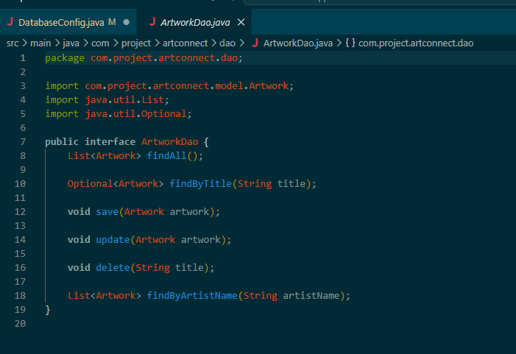
Artist DAO
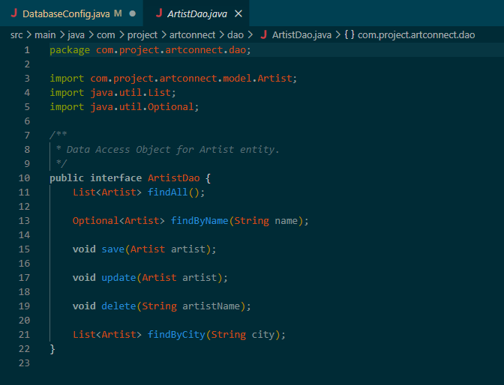

Community member DAO
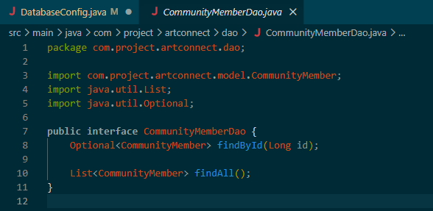

The JDBC DAO classes are in the github in the file :
- org.project.artconnect.persistence.

2. Services
- Adapt the service layer to use JDBC DAOs instead of in-memory services. Always respect the code architecture!
- You can keep an InMemoryXxxService implementation for testing, but the final application must use services connected to the database.
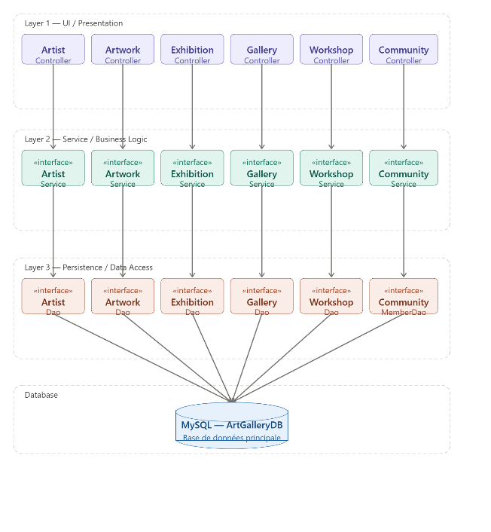
The application follows a strict 3-tier architecture where each layer has a single responsibility and only communicates with its adjacent layers:
| Layer | Responsibility
| UI (Controllers) | Display data, capture user input
| Service | Business rules, validation, orchestration
| DAO (Persistence) | SQL queries, ResultSet mapping

How In-Memory worked before : The InMemoryArtistService (for exemple) stored everything in a Java map in RAM.
The problem was that all data was lost every time the application restarted. There was no persistence.

Now, with JDBC, the JdbcArtistService delegates everything to a JdbcArtistDao which executes real SQL queries. Follow the structure of the
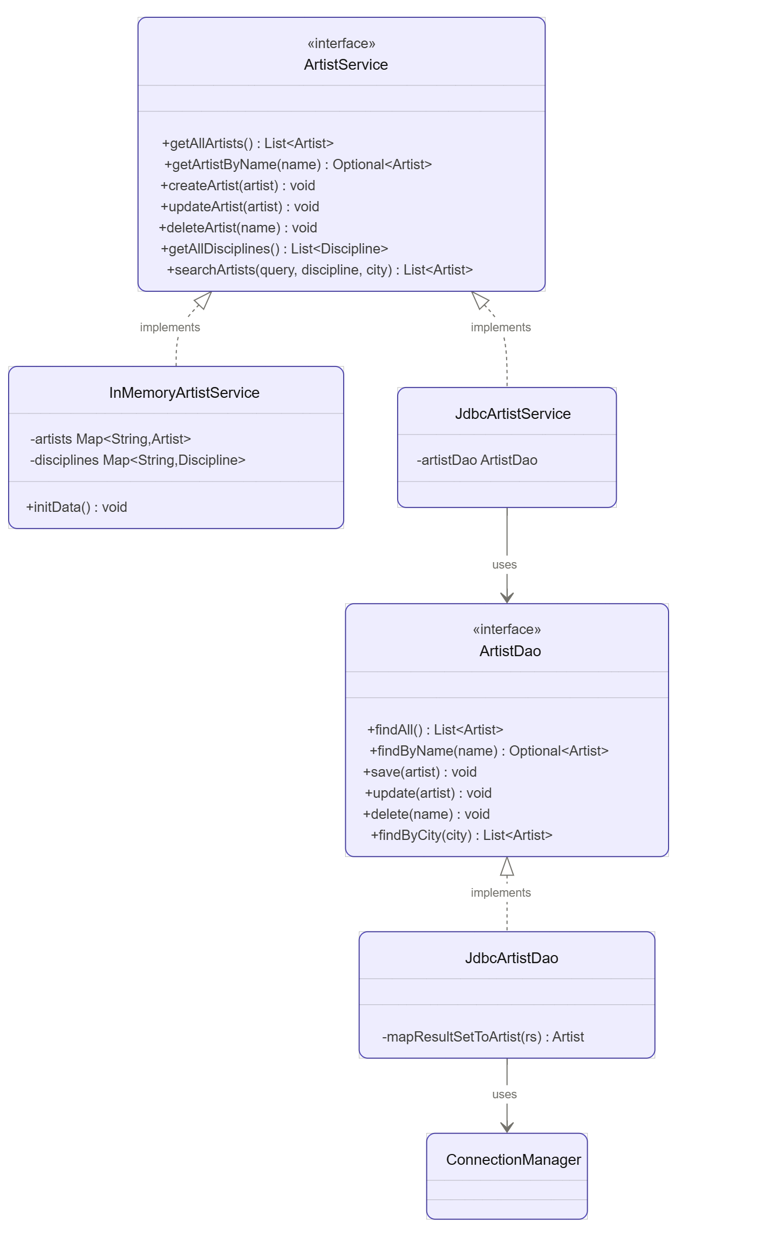
The ArtistService interface can either use the implementation InMemoryArtistSercice (what was there before and still here for test) or the new version with JdbcArtistService that uses the AristDao interface to make the SQL querry (either List / Update / Create / Delete)

So the architecture of the code remains the same as it was asked to !

3. Connection to the database
- Complete the DatabaseConfig configuration class (or equivalent) to provide a valid JDBC connection to your ArtConnect database.
- Configure the URL, username, and password in a clearly indicated location (configuration file, constants, etc.).
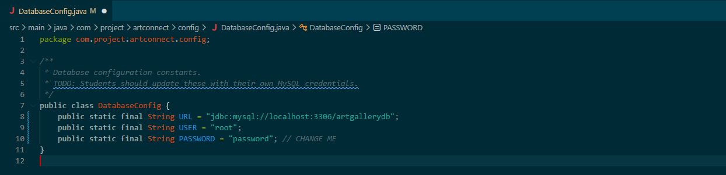
All the constraint are in the databaseconfig.java folder. It has a proper location!

4. Adaptation of the UI
- Without deeply modifying the graphical interface, ensure that the main actions (list, add, modify, delete) now use the services connected to the database.
- Verify that the different screens display data from your database and that CRUD operations are persistent.

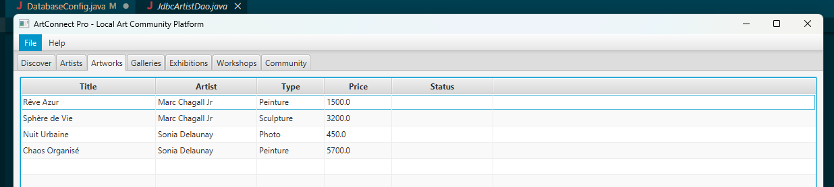
We modify the price of Chaos Organisé from 5600.0 to 5700.0 with the new interface :
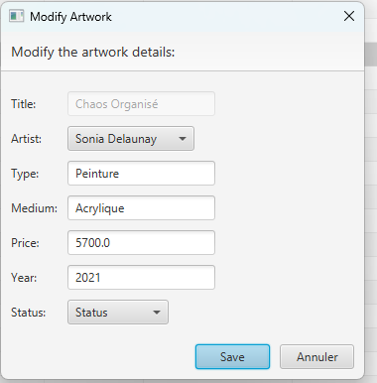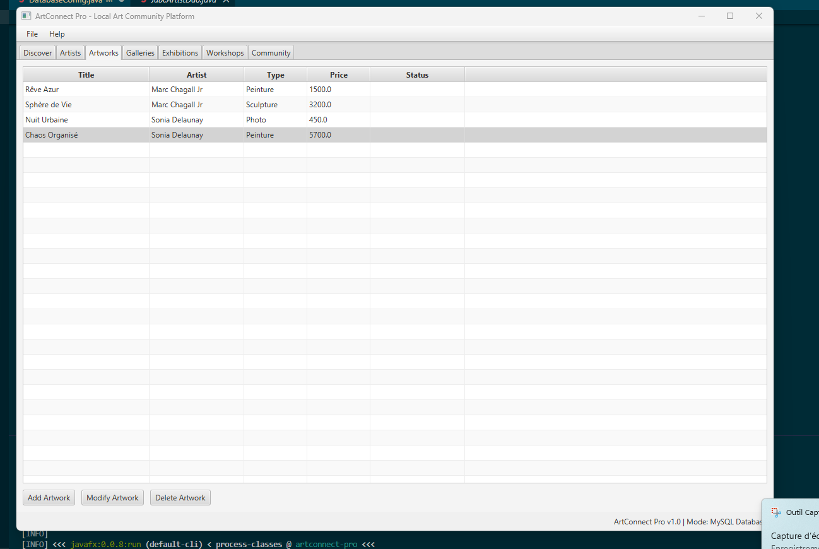
When we restart the app the price remains unchanged = success.
Moreover, the data are updated in the project only if we connect the java app to the database where we have inserted the data (to have something as a base).
All the other actions: Add / Modify / Delete / List are perfectly working for all the class i.e. for Artist / Artworks and Exhibitions

